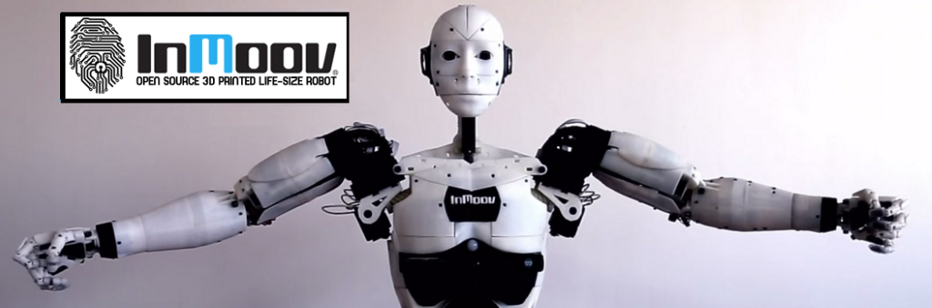

**Presentation & Subject Analysis**

**Identification:**

|  |  |
| --- | --- |
| Project Title | Robot Cognitif |
| Project Number | 65 |
| Team Referent | MARTIN Jérémy |
| Other members in team | EKHTERAEI Aria, GUILLAUME Thomas, MEZOUAR Chloé |
| Team Mentor | Jean-Philippe LELIEVRE |
| Project Partner | DaVinciBot |

**Context:**

One of the big capacity which allows human being to be integrated in society is his ability to recognize the face of another human being. As the robot InMoov is made to be in contact with people and to interact with them, to integrate a facial recognition could allow it to be better perceived by people around it.

On the one hand, the goal of this project is facial recognition in a global way. The head of the robot should be able to follow the person in front of it. On another hand, InMoov should be able to recognize a familiar face and to greet him. If the person is unknown, a registration procedure should be proposed.

**First State of the Art:** 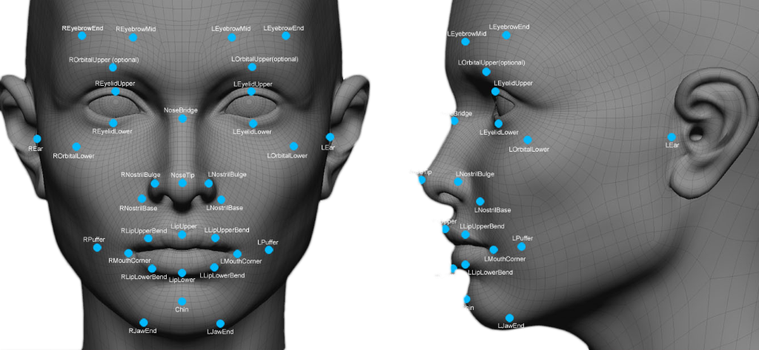

Facial recognition is a software application which aims to recognize a person thanks to her face automatically. It's different from facial detection, which simply identify the presence of a face in the field of view.

The goal of our PI² project is to create a facial recognition able to determine, with the best precision possible, the person in front of it with the help of the school Léonard de Vinci data base. The determination of her feelings can be a bonus. To do that, we have searched every similar project or which already exist. So first, we began searching what was already done on the InMoov robot itself.

On InMoov, there is already a facial recognition project which only allows the person in front of the robot to open a session for a chatbot. So, there is no recognition of the facial features for the detection of feelings. Yet, it includes an eye-tracker to center the face, facilitating the recognition of the person. (<http://inmoov.fr/forums/topic/point-davancement-de-mon-inmoov/>)

A gesture recognition project, thanks to the Kinect integrated in the chest of InMoov, allows the robot to replicate every move of the person in front of it. It detects all the parts of the body, head included with facial features. Unfortunately, it is not used currently in InMoov projects. (<https://www.generationrobots.com/fr/401430-capteur-microsoft-kinect.html>)

Besides InMoov, facial recognition begins having a real presence in robotics. For instance, at KFC in China, a little robot scans the face of each client thanks to facial recognition. Thus, the robot proposes them their last menu if they are already known, or propose them a menu which could potentially interest them according to their age, their sex, their corpulence. (<http://www.europe1.fr/emissions/la-une-de-leco/kfc-lance-la-reconnaissance-faciale-pour-faciliter-les-commandes-2940650>)

Other than robotics, many uses of facial recognition and projects about it exist, like on smartphones for the unlocking of the device. It is the case of the Samsung Galaxy S8/S8+/Note8 and even the new iPhone X. Thus, we can find free software of facial recognition like OpenCV which allows shape recognition, facial detection, the production of an HDR image from several expositions and learning with a machine learning module coded in C++, Java and Python on Windows, Linux, Android, iOS, or the Google API made for it. Some social network like Facebook also use facial recognition to identify people on pictures.

A French Start-up created a device which allows to measure a degree of satisfaction of the faces it detects. This tool could be used by the cameras in stores, to associate a client's degree of satisfaction with the product in front of him. (<http://www.20minutes.fr/high-tech/2019339-20170224-souriez-emotions-detectees-intelligence-artificielle>)

Several patterns of facial recognition were proposed in the last few years, according to two main axes: the recognition from static images and the recognition from sequences of images. Works in this field within different lightning conditions, different facial expression and orientation can be categorized into two distinct field depending on the fact that it's a geometric approach or a globalized one.

The existing approach can be divided into three groups: Local, global and hybrid

1) Local approach

Locals approach about the facial recognition are based on models and works thanks to a separate treatment of different places of a facial picture. The models used are based on the knowledge that we have about facial morphology. Most of the time, it means that we have to detect/extract local facial characteristics.

2) Global approach

Global approach takes a facial picture as a whole and use some known statistics analytics technics. The idea is to project the facial picture, pre-vectorized, into a space of a smaller dimension where the recognition is supposed to be easier

3) Hybrid approach

Hybrids methods results of the association of local and global methods. It combines the detection of local characteristics and the extraction of global characteristics. The hybrids technic tries to take advantages of the both methods previously talked about.

Like all systems, the facial recognition has its limits. There's different ways to fake the detection like: showing a face picture within a close distance to the camera (this technic doesn't work with 3D recognition though), showing a facial video or by wearing a special make-up. To fix those breaches, we can analyze different elements such as: blinking, micro movement of the interlocutor, the texture, etc. We can also multiply the different facial posture or use a microphone and ask the user to talk. The database size, the number of frames captured, the luminosity, the quality of the picture or the proximity of the lens to the picture, are all different parameters allowing to increase the viability of the facial recognition.

The mathematical origins of the facial recognition: the eigenfaces. The eigenface method used by Turk and Pentland in 1991, allow to recognize a person without taking interest in special characteristics such as eye color, facial shape, nose shape. In fact, every face is described as a combination of vectors: the eigenfaces. In the following example, the picture on the left is the sum of:

* The second one (average of every images)
* -14.4 of the 3rd one
* +5.4 of the 4th
* +0.3 of the 5th
* +3.4 of the 6th
* -0.1of the 7th

facemoyenneeigenface 1eigenface 2eigenface 3eigenface 4eigenface 5

(<http://cours-info.iut-bm.univ-fcomte.fr/wiki/pmwiki.php/TP/EigenFaces>)

This technic of recognition uses the Principal Component Analysis method (PCA), or the Singular Values Decomposition method (SVD). That method allows to reduce the quantity of work to simplify the data and their interpretations. The goal is to take into consideration the necessary information for the recognition, with a good success rate, of a face among others.

**Objectives and sub-objectives definitions:**

General facial detection

Allow the robot to detect a face

Give the robot the ability to follow an interlocutor thanks to his head

Targeted facial detection

Realize facial features detection

Create and test a database containing different information about a face (facial features + identity)

Elaborate a simple recording serial

Link and applicate the previous points

Incorporate the whole into inMoov

Limites:

Recording phase not difficult, achievable by someone external to the project.

Using the same equipment as InMoov (camera, Arduino, Python, etc)

**Valuing:**

What is valuing your project?

The development of new technologies, allows us today to print a robot at home and to be able to buy electronic components at a lower cost. Thus our project is valued first of all by its accessibility: in addition to being free, most of the software used are also open source (Python, OpenCV, ...).

In addition our project is based on facial recognition, it is used to users to be recognized by the robot, for example, opening chatbot sessions, securing functionality, etc. We will use free software, this way our solution can be deployed easily and freely by all people.

How can the valuing be complete?

The valuing could be even more complete if the Inmoov community used our solution, so we would have feedback to improve the facial recognition and that could make us known in the world of face recognition and robotics.